**Week 4 Discussion Forum 2 – GitHub**

Vicki Kelm

The University of Arizona Global Campus

CST 499: Capstone for Computer Software Technology

Dr. Amjad Alkilani

January 18, 2024

**Week 4 Discussion Forum 2 – GitHub**

“Version control systems are a category of software tools that helps in recording changes made to files by keeping track of modifications done in the code” (GeeksforGeeks, 2022). The first task of the assignment is to search the GitHub online repository and select any open project to write about. This paper will discuss the chosen GitHub project, will compare the different version control systems to include: Git, SVN, and CVS, discuss key features provided via any version control system, discuss how the different options chosen supports these features, and last to develop an objective way to select the option determined to be best.

**Chosen GitHub Project from the online repository with details**

**GitHub Project**: leantime

[Leantime (github.com)](https://github.com/Leantime)

[Leantime - Open Source Project Management Software](https://leantime.io/)

<https://leantime.io>

* **Start Date**: November 11, 2015 (First pre-release of the new system, v0.9.5-alpha)
* **Number of active members**: 127 followers, 3.7k stars, 6 sponsors, 110 contributors
* **Date of latest update**: January 16, 2024 v3.0.0
* **Key description of the project**: Leantime is a goals focused project management system for non-project managers. Building with ADHD, Autism, and dyslexia in mind.
* **Activity level**: Ranges from yesterday, 01/16/2024 through June 21, 2022
* **Language used**: PHP, JavaScript, HTML, HCL, Dockerfile
* **Number of contributions that can be made and accepted**: several since inception

Below shows contributions for the past week:

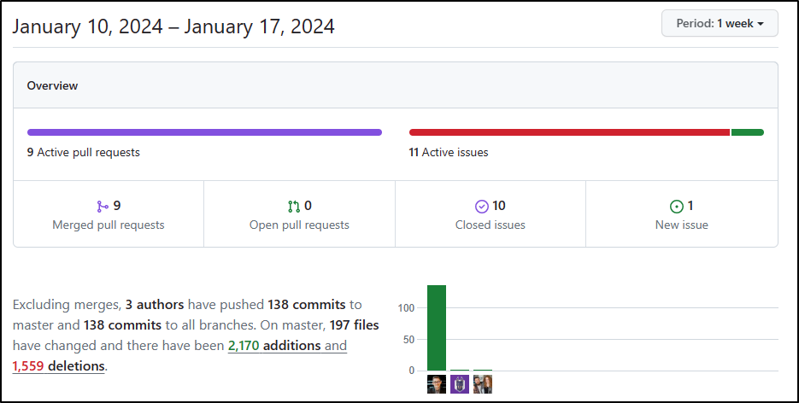

**Compare the different version control systems: Git, SVN, and CVS**

“Version control systems have been around since the 1970s” (Tsui, Karam, & Bernal, p. 204). VCSs use repositories to store code, other artifacts, provides a means at which to keep track of different versions, and a history of the contributors and their contributions.

* **Git**: A distributed version control system, which means that each developer has a copy of the entire codebase and the entire history of the codebase on their local machine (W3schools, n.d.).
  + Emphasis on speed and data integrity, no centralized connectivity is needed.
  + Powerful and cheap branching with easy merge, each developer has their own repository and local copy to change history.
* **SVN**: Also centralized
  + Apache Subversion open-source software version and revision control system under the Apache license (Difference Between GIT and SVN, 2022).
  + Manages files and folders present in the repository, operates across the network so multiple people are able to work on it.
* **CVS**: A centralized version control system, which means there is a single central repository that stores the entire codebase and history (W3schools, n.d.).
  + Free and open-source VCS released in the 1990s (Software, n.d.).
  + Not widely used today

**Discuss the key features provided via any version control system**

**Key features of Git**:

* Distributed system
* Branching
* Compatibility
* Non-linear development
* Lightweight
* Open source

**Key features of SVN**:

* Directories are versioned
* Copying, deleting, and renaming
* Free-form versioned metadata
* Atomic commits
* Branching and tagging
* Merge tracking
* File locking

**Discuss how the different options chosen supports the features**

A local VCS will be the most secure as only those with access to the local machine are able to access the project. Distributed version control systems offer the greatest data integrity due to it being stored in multiple places.

**Develop an objective way to select the option determined to be best**

“Although there are many different systems, the most popular nowadays is git” (Tsui, Karam, & Bernal, sect. 9.4.4). Git is a free and open-source distributed version control system and is the most widely used in the world based on a Stack Overflow Developer Survey of more than 93% of developers who use Git. Microsoft also states that, “Git has become the worldwide standard for version control”.

Objectively there are several benefits to Git. The benefits include: simultaneous development, faster releases, built-in integration, strong community support, works with any team, pull requests, and branch policies. Several of these benefits are discussed below.

* **Simultaneous development**: A local copy of code is owned by everyone and can be worked on simultaneously within their own branches.
* **Faster releases**: Branches allow for flexible and simultaneous development, feature branches contain work in progress which get merged into the main branch upon being completed where high-quality code is released from.
* **Built-in integration**: Due to its popularity, Git integrates into most tools and products (What is Git?, 2022), simplifies day-to-day workflow.
* **Git works with any team**: The use of Git with a source code management tool boosts a team’s productivity with the encouragement of collaboration, enforcing policies, automating processes, and improving visibility and traceability.

**Conclusion**

This paper described the chosen open GitHub project from the online repository, compared the different version control systems including: Git, SVN, and CVS, discussed key features provided via the Git and SVN version control systems, discussed how the different options chosen supports those features, and lastly developed an objective way to select the option determined to be best.

**References**

GeeksforGeeks. (2022, June 21). *Difference Between GIT and SVN*. <https://www.geeksforgeeks.org/difference-between-git-and-svn>

GeeksforGeeks. (2022, June 29). *Version Control Systems*. <https://www.geeksforgeeks.org/version-control-systems/>

Microsoft. (2022, November 28). *What is Git*? <https://learn.microsoft.com/en-us/devops/develop/git/what-is-git>

Software. (n.d.). *What is Version Control*? *Why it Matters*. <https://www.software.com/devops-guides/version-control-guide>

Tsui, F., Karam, O., & Bernal, B. (2018). [Essentials of software engineering](https://uagc.instructure.com/courses/126521/modules/items/6439323)(4th ed.). Jones & Bartlett Learning.

W3schools. (n.d.). *Git Vs CVS Vs SVN*. <https://www.w3schools.blog/git-vs-cvs-vs-svn>